RAJSHAHI UNIVERSITY OF ENGINEERING & TECHNOLOGY



Course no : CSE-2188

Lab Report on

Wallet App

Submitted By: Submitted To:

Group- 02 Md.Faisal Rahman Badal,

SM Shafayet Jamil 1908006 Lecturer, Department of

Rehnuma Taskin 1908007 Mechatronics Engineering

Sayeed Abdullah 1908008 Md.Mehedi Hasan, Lecturer

M. Nasimul huq 1908009 Department of

Laboni Mostofa 1908010 Mechatronics Engineering

**Introduction:** A wallet app is an application where you can organize your cash , bank accounts, or different financial occasions.

The application not only keep track of your expences but also assembles your personal info i.e. Student ID, Bank Accounts, and many more.

**Features:** The key features of our app was:-

* + Add new wallet.
  + Update existing wallet.
  + Remove Wallet.
  + Add custom category by user.
  + Add your bank accounts.
  + Student ID card info.
  + Track your expenses based on your wallet.

**App Screenshots:**

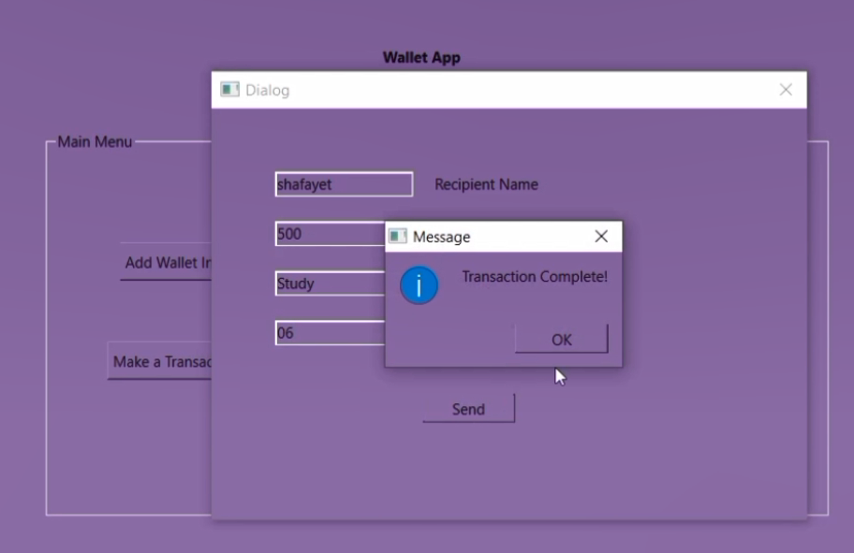

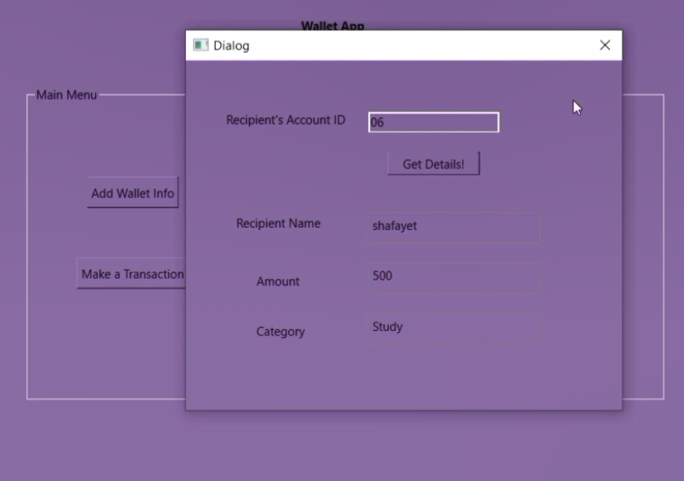

**Code Explanation:** In source code written in codeblocks , we have created structure & methods for each functionality . We have used file handling codes in every methods . In menu function we used switch-case operations for users to choose from multiple options . In creating GUI using QT , firstly we have created a project file & as a template we used QT GUI widget application. We will be having a source file, QT UI file & a header file as a default . Inside the mainwindow.cpp file we have created a class named MainWindow which inherits QmainWindow class defined in the Qmainwindow.h header file & in private slots we have declared all the on_pushbutton_clicked functions. We created ui pointer object for accessing all the widget tht we have created. We also declared pointer object for every other widgets. So for the on_pushbutton_clicked functions, we have taken all the inputs by text() method & stored in QString variable. Then by tostdstring function we converted them in string & in the for loops we made character arrays for writing inside file. Finally we have used setStylesheet method for changing background color & we used hexadecimal code for color. We showed information by QMessagebox method.

**Discussion:** We have used C language for our source code & same logic written in QT creator application in C++. Tools used were codeblocks, QT. At first , when we got the project we did not plan to create GUI , as in our groups two members were not able to contribute, much responsibility & pressure fall upon remaining three members. We learned how to create GUI using QT for the first time & it was a challenging & exciting process . While coding we found some errors which were mitigated taking help from internet & discussing among group members.

**Conclusion:** The task was to create a wallet app along with GUI & we were successful in doing so . We did not have any prior knowledge in QT before but with the process we learned how to do so . The advices from our course advisors were really helpful & we tried to full fill all the requirements appropriately . Learning from the mistakes is the achievements for us in this project .